**Amazon EC2-Compute Cloud**

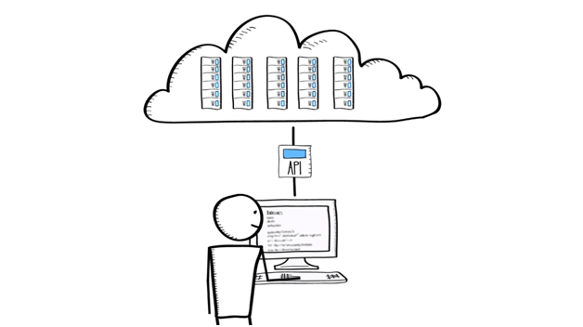

**Amazon EC2:** **This is a web service, have a feature of resizable compute in the cloud**. It makes easy for developers in the process of web-scale computing.

Amazon EC2’s simple web service interface allows you to obtain and configure capacity with minimal friction. It provides you with complete control of your computing resources and lets you run on Amazon’s proven computing environment

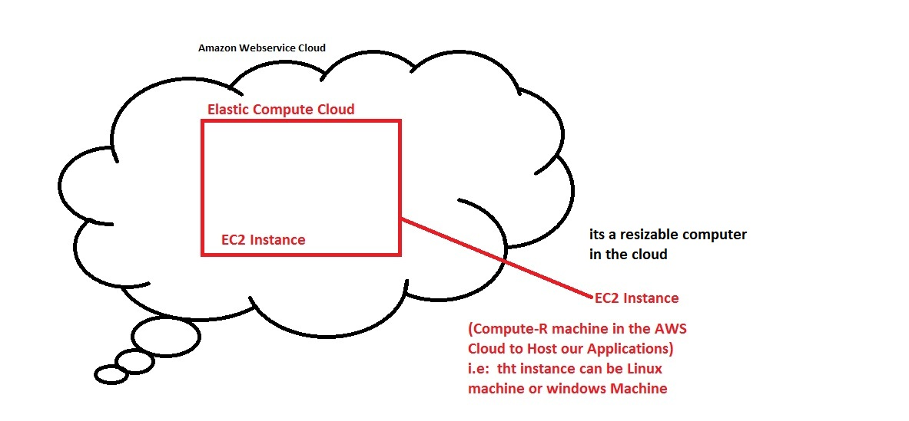

Amazon EC2 reduces the time required to obtain and boot new server instances to minutes, allowing you to quickly scale capacity, both up and down, as your computing requirements change.

## ****Benefits :****

**Elastic Web-Scale Computing :** It is capable to make the variations in capacity within minutes, which can be enhancing it or reducing it. We might pay one or thousands of server instances concurrently since there are all controlled with web service APIs, the application belongs to you may automatically level itself up and down according to the requirements.

**Completely Controlled :** Being a client you have an intact control on all the instances of Amazon EC2. If you wish to retain the data on your boot partition, then it allows you to stop the instance. Later the instance can be restarted using the web service APIs. The web service APIs used also to reboot the instances. Access for console output will be provided too.

**Flexible Cloud Hosting Services :**  It will permit you to choose instance storage space, memory configuration, CPU and boot partition sizes that are best for the applications and the system you selected. For example, your selected OS contains several Linux distributions and Microsoft Windows server10.

**Reliable :** Amazon, is known for reliability and the payment amount for replacement of instances will be knowable. The service will be available within the data centers and network infrastructure. The SLA has promised that it will provide 99.95% availability for every region. SLA stands for service Level Agreement**.**

**Secure :** It will facilitate the security and robust networking operations for your computer property by adopting the component is known as Amazon Virtual Private Cloud. The compute instances are placed within VPC by an IP address sort that you indicate.

**ACLs (Access Control Lists)-**permits to manage inbound and outbound network access.

The present IT infrastructure can be connected to the resources within your VPC with the help of industry customary encrypted IPSec VPN connections.

**Inexpensive :** The services provided by the Amazon EC2 are inexpensive. The rate of the consumption of the compute power is more than the amount you pay for it.

**Types of Amazon Instances**

## ****On-demand Instances :****

The payment for the service of computing can be done **on hourly basis with no long-term assurance**. Thus it helps you to come out from the issues of purchasing, maintaining and planning of hardware and replaces the usual huge preset costs into lesser erratic costs. With the aid of this you can delete the requirement of buying the “safety net” capability to manage intermittent traffic spikes.

## ****Reserved Instances :****

With the aid of reserved instances, it is possible to reserve the computing capacity for **1 to 3 years.** The reserved instance marketplace can be used to sell Reserved Instances if your requirements will get change.

For example: if you wish to shift to a innovative AWS region, then transform into a new instance form.

## ****Spot Instances :****

This is an instance permits to tender on idle EC2’s capacity and execute those instances until the bid beats the current Spot cost(Whenever we. The Spot value or cost varies sometimes depends on supply and demand, and the clients whose tender reach or go beyond it gain access to the available Spot Instances. **If you are aware that when your applications required to run, Spot instances can considerably lesser.**